ICAS III
Jatinangor, 1-2 Nov, 2023

Analysis of the Cause of the Increase in Diabetes Melitus Cases in West Java Province in 2020-2022 Using Negative Binomial Regression

Anggie Alnurin Prasetya*¹, Anindya Nitisari2, Ardiana Dwi Cahyanisa3, Hallen Naafi Aliya Rachman4 and Vira Annisa Trivita5

^{1,2,3,4,5} Department of Statistics, Padjadjaran University, INDONESIA.
(E-mail: anggie21001@mail.unpad.ac.id, anindya21002@mail.unpad.ac.id, ardiana22001@mail.unpad.ac.id, hallen21001@mail.unpad.ac.id, vira21001@mail.unpad.ac.id)

ABSTRACT
Diabetes Mellitus is a chronic disease characterized by elevated blood sugar (hyperglycemia) and glucose intolerance. The high number of people with Diabetes Mellitus is closely related to modern lifestyles such as unhealthy diets, economic factors, and poverty. This disease is still a serious problem in various provinces in Indonesia, one of which is West Java province. The number of people with Diabetes Mellitus in West Java Province in 2022 was 644,704 people. This study aims to identify whether the consumption levels of sugar, coffee, tea powder, tea bags, other beverage ingredients, the gini index, and the poverty line affect the number of people with Diabetes Mellitus in West Java.
The method used in this research is Poisson regression. This regression model can be used to analyze the relationship between response variables that are not normally distributed and discrete data with one or more predictor variables. However, in this study overdispersion occurred, which means that the Poisson regression model is not suitable for the data used. Therefore, this study was handled using the Negative Binomial distribution.
Based on the results of the analysis using the Negative Binomial regression model, it was found that an increase in the number of people with diabetes mellitus followed an increase in the average consumption of coffee and tea bags in West Java. Meanwhile, an increase in the number of people with Diabetes Mellitus follows a decrease in the average consumption of tea powder, other beverage ingredients, the gini index, and the poverty line. The AIC value of 1825.9 is smaller than Poisson regression, so Negative Binomial regression was chosen to model the data.

Keywords: Diabetes Melitus, Overdispersion, Negative Binomial Regression, West Java

Table 1. Pearson correlation between variables

Variable | Coffee | Tea Powder | Tea Bags | Other Beverage Ingredients | Gini Index | Poverty Line
Coffee | 1
Tea Powder | 1.1046 | 1
Tea Bags | 0.4546 | -0.2555 | 1
Other Beverage Ingredients | 0.0037 | -0.1251 | 0.2844 | 1
Gini Index | -0.1000 | -0.5052 | 0.3667 | 0.3667 | 1
Poverty Line | 0.2949 | -0.3641 | 0.3081 | 0.3081 | 0.4344 | 1

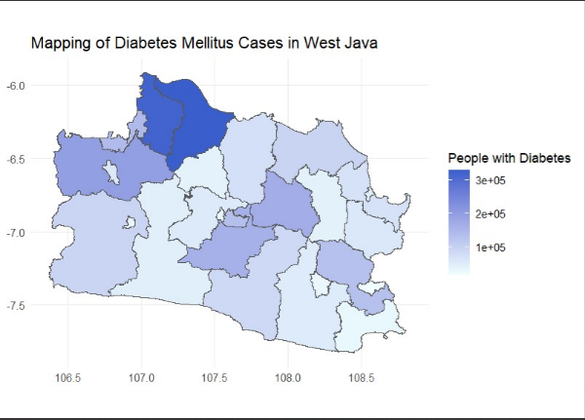
Figure 1. Map of the distribution of the number of Diabetes Melitus patient in West Java

References:
[1] Kurniawaty, E., & Yanita, B. (2016). Faktor-faktor yang Berhubungan dengan Kejadian Diabetes Melitus Tipe II. Jurnal Majority, 5(2), 27-31.
[2] American Diabetes Mellitus Association. (2014). Standards of Medical Care In Diabetes Mellitus. Diabetes Care, 37(SUPPL.1), 14–80.
[3] Murtiningsih, M. K., Pandelaki, K., & Sedli, B. P. (2021). Gaya Hidup sebagai Faktor Risiko Diabetes Melitus Tipe 2. e-CliniC, 9(2), 328-333.
[4] Kementrian Kesehatan RI. (2020). Infodatin Diabetes Melitus 2020, Jakarta: Kemenkes RI.
[5] Saputri, R. D. (2020). Komplikasi Sistemik pada Pasien Diabetes Melitus Tipe 2. Jurnal Ilmiah Kesehatan Sandi Husada, 9(1), 230-236.
[6] Dinas Kesehatan Jawa Barat. (2022). "Jumlah Penderita Diabetes Melitus Berdasarkan Kabupaten/Kota di Jawa Barat ." Dinkes Jawa Barat.
[7] Waryana. (2016). Promosi Kesehatan Penyuluhan dan Pemberdayaan Masyarakat. Yogyakarta : Nuha Medika.
[8] Susilowati, A. A., & Waskita, K. N. (2019). Pengaruh Pola Makan terhadap Potensi Resiko Penyakit Diabetes Melitus. Jurnal Mandala Pharmacon Indonesia, 5(01), 43-47.
[9] Abdulrehman, M. S., Woith, W., Jenkins, S., Kossman, S., & Hunter, G. L. (2016). Exploring Cultural Influences of Self-Management of Diabetes Mellitus in Coastal Kenya. Global Qualitative Nursing Research, 3(1-13). https://journals.sagepub.com/doi/pdf/10.1177/2333393616641825
[10] Jazilah, Wijono P., & Sudargo T. (2003). Hubungan Tingkat Pengetahuan, Sikap, Dan Praktik (PSP) Penderita Diabetes Melitus Mengenai Pengelolaan Diabetes Melitus Dengan Kendali Kadar Glukosa Darah. Sains Kesehatan, 16(3), 417. https://repository.ugm.ac.id/59678/
[11] BPS Provinsi Jawa Barat. (2022). "Gini Rasio Kabupaten/Kota.", “Garis Kemiskinan Menurut Kab/Kota (Rupiah/Perkapita/Perbulan)”, dan "Rata-rata Konsumsi Perkapita Seminggu Menurut Kelompok Bahan Minuman Per Kabupaten/Kota (Satuan Komoditas)." BPS Jawa Barat.
[12] Cahyandari, R. (2014). Pengujian Overdispersion pada Model Regresi Poisson (Studi Kasus: Laka Lantas Mobil Penumpang di Provinsi Jawa Barat). Statistika, 14(2), 69-76.
[13] Sugiyono. (2017). Metode Penelitian Kuantitatif, Kualitatif, dan R&D. Alfabeta:
Bandung.

