ICAS III
Jatinangor, 1-2 Nov, 2023

Analysis of Factors Explaining Crime Rates in North Sumatra 2019-2021 Using Geographically and Temporally Weighted Regression (GTWR)

Yekti Widyaningsih*¹, Eslim Suyangsu Rohmanullah2 and Siti Nurrohmah3

^{1, 2, 3} Statistics, Universitas Indonesia, Indonesia.
(E-mail: yekti@sci.ui.ac.id*, eslim.suyangsu@sci.ui.ac.id, snurrohmah@sci.ui.ac.id)

ABSTRACT
The development of the era of globalization can lead to competition that may drive individuals or groups to engage in criminal activities using illegal or dishonest methods to achieve an advantage or surpass competitors. Crime in Indonesia is inevitably increasing, whether reported by the media. This phenomenon has auxiliary data on the increasing number of criminal offenses in Indonesia over the past three years. In order to mitigate the adverse effects of competition that may lead to criminal behavior and accomplish 16 of the Sustainable Development Goals (SDGs), which aim to create a safer environment for society, especially in the era of globalization, it is necessary to understand the factors that can explain the crime rates. The objective of this study was to analyze the factors that explained the crime rates in North Sumatra using the Geographically and Temporally Weighted Regression (GTWR) method with weighting functions adaptive Bisquare kernel. The GTWR method is an extension of the Geographically Weighted Regression (GWR) method, which considers spatial and temporal heterogeneity. This study used explanatory variables such as Population Density (KPn), Number of Poor People (JPM), Poverty Line (GKm), Average Length of Schooling (RLS), Open Unemployment Rate (TPT), and Adjusted Per Capita Expenditure (PKD). The results of this study obtained 10 areas groups based on the significance of different explanatory variables for each year consisting of 3 broad groups in 2019, 4 broad groups in 2020, and 3 broad groups in 2021.

Keywords: Adaptive Kernel Bisquare, Spatial and Temporal Heterogeneity, Weighting Function

Table 1. Significance explanatory variable in each year

Year | Regency/Municipal | Significant Variables
2019 | Asahan, Batu Bara, Dairi, Gunungsitoli, Humbang Hasundutan, Karo, Binjai, Tanjung Balai, Labuhan Batu, Labuhan Batu Utara, Langkat, Mandailing Natal, Nias, Nias Barat, Nias Selatan, Nias Utara, Padangsidimpuan, Pakpak Bharat, Pematang Siantar, Samosir, Serdang Bedagai, Sibolga, Simalungun, Tapanuli Selatan, Tapanuli Tengah, Tapanuli Utara, Tebing Tinggi, dan Toba Samosir | KPn, RLS
 | Labuhan Batu Selatan, Padang Lawas, dan Padang Lawas Utara | KPn, RLS, PKD
 | Deli Serdang dan Medan | KPn, JPM, RLS
2020 | Asahan, Batu Bara, Dairi, Gunungsitoli, Humbang Hasundutan, Karo, Tanjung Balai, Labuhan Batu, Labuhan Batu Selatan, Labuhan Batu Utara, Nias Barat, Nias Selatan, Nias Utara, Padang Lawas, Padang Lawas Utara, Padangsidimpuan, Pakpak Bharat, Pematang Siantar, Samosir, Serdang Bedagai, Sibolga, Simalungun, Tapanuli Selatan, Tapanuli Tengah, dan Tebing Tinggi | KPn, PKD
 | Deli Serdang dan Nias | KPn, JPM, PKD
 | Binjai dan Medan | KPn, JPM
 | Langkat, Mandailing Natal, Tapanuli Utara, dan Toba Samosir | KPn
2021 | Asahan, Batu Bara, Dairi, Deli Serdang, Gunungsitoli, Humbang Hasundutan, Karo, Binjai, Medan, Tanjung Balai, Labuhan Batu, Labuhan Batu Selatan, Labuhan Batu Utara, Langkat, Mandailing  Natal, Nias Barat, Nias Selatan, Nias Utara, Padang Lawas Utara, Pakpak Bharat, Pematang Siantar, Samosir, Serdang Bedagai, Sibolga, Simalungun, Tapanuli Selatan, Tapanuli Tengah, Tapanuli Utara, dan Toba Samosir | KPn, JPM, RLS, GKm, TPT, PKD
 | Nias, Padang Lawas, dan Padangsidimpuan | KPn, JPM, GKm, TPT, PKD
 | Tebing Tinggi | KPn, JPM, RLS, GKm, PKD

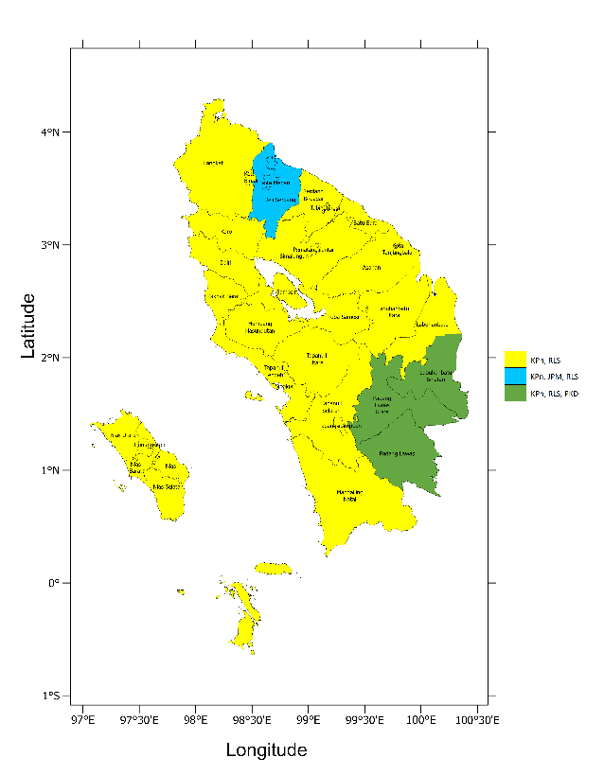
Figure 1. Cluster map of significant variables in 2019

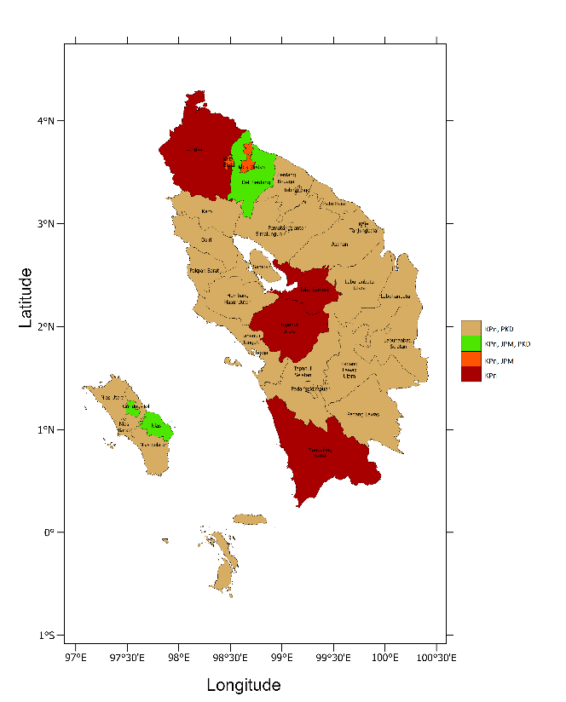
Figure 2. Cluster map of significant variables in 2020

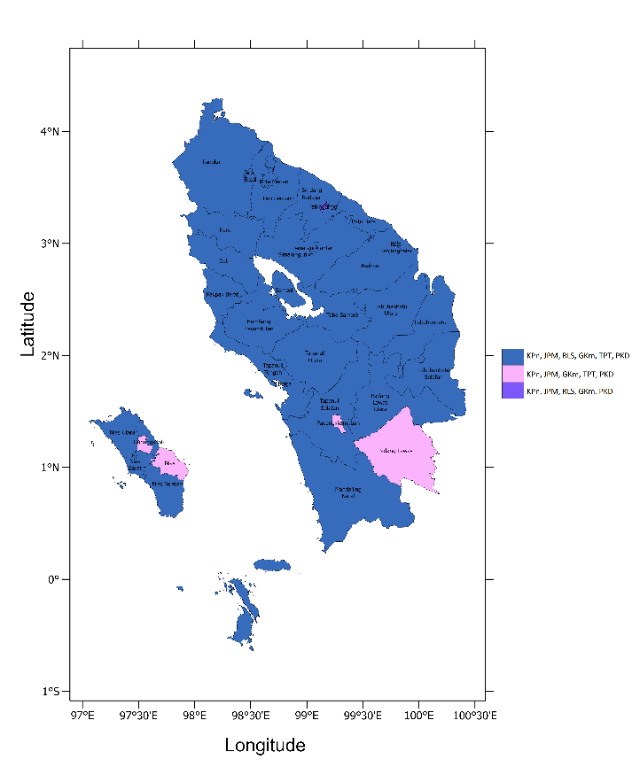
Figure 3. Cluster map of significant variables in 2021

Acknowledgment: The Directorate of Research and Development of Universitas Indonesia (DRPM UI) funded this study as an additional paper through a grant of Hibah Publikasi Terindeks Internasional (PUTI) Q2 2022—2023 No.: NKB-668/UN2.RST/HKP.05.00/2022.

References:
[1] Brunsdon, C., Fotheringham, A. S., & Charlton, M. E. (1996). Geographically weighted regression: a method for exploring spatial nonstationarity. Geographical Analysis, 28(4), 281–298. https://doi.org/10.1111/J.1538-4632.1996.TB00936.X
[2] Chen, Y., Chen, M., Huang, B., Wu, C., & Shi, W. (2021). Modeling the Spatiotemporal Association Between COVID-19 Transmission and Population Mobility Using Geographically and Temporally Weighted Regression. GeoHealth, 5(5). https://doi.org/10.1029/2021GH000402
[3] Chrishananda, K. B. T., & Chernovita, H. P. (2020). Analisis Spasial Pola Kriminalitas di Kota Salatiga. Jurnal Spasial: Penelitian, Terapan Ilmu Geografidan Pendidikan Geografi, 7(1), 18–29. https://doi.org/https://doi.org/10.22202/js.v7i1.4037
[3] Debataraja, N. N., Kusnandar, D., Mahalalita, R., & Imro’ah, N. (2021). Penerapan Model Geographically and Temporally Weighted Regression Pada Kecelakaan Lalu Lintas. Jurnal Siger Matematika, 2(1), 19–24.
[4] Fotheringham, A. S., Crespo, R., & Yao, J. (2015). Geographical and Temporal Weighted Regression (GTWR). Geographical Analysis, 47(4), 431–452. https://doi.org/10.1111/gean.12071
[5] Handayani, D., Artari, A. F., Safitri, W., Rahayu, W., & Santi, V. M. (2021). Count Regression Models for Analyzing Crime Rates in the East Java Province. Journal of Physics: Conference Series, 2123(1). https://doi.org/10.1088/1742-6596/2123/1/012028
[6] Harianto, Nugroho, W. H., & Sumarminingsih, E. (2021). Geographically and Temporally Weighted Regression Model with Gaussian Kernel Weighted Function and Bisquare Kernel Weighted Function. IOP Conference Series: Materials Science and Engineering, 1115(1). https://doi.org/10.1088/1757-899x/1115/1/012063
[7] Haryanto, S., Aidi, M. N., & Djuraidah, A. (2019). Analysis of the Geographically and Temporally Weighted Regression (GTWR) of the GRDP the Construction Sector in Java Island. Forum Geografi, 33(1), 129–138.
[8] Huang, B., Wu, B., & Barry, M. (2010). Geographically and temporally weighted regression for modeling spatio-temporal variation in house prices. International Journal of Geographical Information Science, 24(3), 383–401. https://doi.org/10.1080/13658810802672469
[9] Ispriyanti, D., Yasin, H., Warsito, B., Hoyyi, A., & Winarso, K. (2017). Mixed Geographically Wighted Regression Using Adaptive Bandwith to Modeling of Air Polutter Standard Index. ARPN Journal of Engineering and Applied Sciences, 12(15), 4477–4482.
[10] Lutfiani, N., & Scolastika Mariani, dan. (2017). Pemodelan Geographically Weighted Regression (GWR) dengan Fungsi Pembobot Kernel Gaussian dan Bi-square. Dalam UNNES Journal of Mathematics (Vol. 5, Nomor 1). http://journal.unnes.ac.id/sju/index.php/ujmUJM8
[11] Mendenhall, William., & Sincich, Terry. (2012). A second course in statistics : regression analysis (D. Lynch, Ed.; 7th ed.). Pearson Education, Inc.
[12] Montgomery, D. C., Peck, E. A., & Vining, G. G. (2012). Introduction to Linear Regression Analysis (5th ed.). John Wiley & Sons, Inc.
[13] Nurhuda, I., & Jaya, I. G. N. M. (2018). Permodelan Kriminal di Jawa Timur dengan Metode Geographically Weighted Regression (GWR). Jurnal Matematika “MANTIK,” 4(2), 150–158. https://doi.org/10.15642/mantik.2018.4.1.150-158
[14] Runadi, T., Widyaningsih, Y., & Lestari, D. (2020). Modeling Total Crime and The Affecting Factors in Central Java Using Geographically Weighted Regression. Journal of Physics: Conference Series, 1442(1). https://doi.org/10.1088/1742-6596/1442/1/012026
[15] Sholihin, M., Soleh, A. M., & Djuraidah, A. (2017). Geographically and Temporally Weighted Regression (GTWR) for Modeling Economic Growth using R. IJCSN-International Journal of Computer Science and Network, 6(6). www.IJCSN.orgImpactFactor:1.5800
[16] Simamora, P. A., & Ratnasari, V. (2014). Pemodelan Persentase Kriminalitas Dan Faktor-Faktor Yang Mempengaruhi Di Jawa Timur Dengan Pendekatan Geographically Weighted Regression (GWR). JURNAL SAINS DAN SENI POMITS, 3(1), 18–23.
[17] Wulandari, F., & Wulandari, I. (2018). Pemodelan Kriminalitas di Provinsi Sumatera Utara dengan Pendekatan Geographically Weighted Regression (GWR) Tahun 2016.
[18] Yasin, H., Warsito, B., Ispriyanti, D., & Hakim, A. R. (2018). Komputasi Geographically and Temporally Weighted Regression Berbasis Graphical User Interface. ProsidingSeminar Nasional VARIANSI, 85–96. http://ojs.unm.ac.id/index.php/variansistatistika

