ICAS III
Jatinangor, 1-2 Nov, 2023

Mapping of District Group in Papua Based on United Nations Indicators of Adequate Drinking Water and Sanitation Access in 2021

Yekti Widyaningsih*¹, Divina Fatriandira2 and Ida Fithriani3

^{1, 2, 3} Department of Mathematics, University of Indonesia, INDONESIA.
(E-mail: yekti@sci.ui.ac.id*, divina.fatriandira@sci.ui.ac.id, ida.f@sci.ui.ac.id)

ABSTRACT

The United Nations is making access to adequate drinking water and proper sanitation one of the Sustainable Development Goals (SDGs). Papua is targeting all districts to achieve 100% universal access to adequate drinking water and sanitation. In 2021 Papua ranked at the bottom of Indonesia in terms of access to adequate drinking water, with 64,92%, and access to proper sanitation, with 40,81%, and there are also disparities between districts within the Papua Province. This study aimed to map and group districts in Papua based on five United Nations indicators of Adequate Drinking Water and Sanitation Access in 2021. This study mapped the districts in Papua based on five variables (Drinking Water Source, Ownership of Disposal Facilities, Proper Type of Disposal, Proper Disposal Site, and Proper Sanitation). The variables were related to United Nations Adequate Drinking Water and Sanitation Access indicators. The method used for mapping the data is Multidimensional Scaling. Multidimensional Scaling is used to create a low-dimensional map that describes the coordinates (position) of objects to other objects based on the similarity of these objects. This study also conducted cluster analysis (hierarchical clustering) on the Multidimensional Scaling mapping data to get a more objective and optimal clusters. The study found that the data can be mapped well on a two-dimensional map, and districts in Papua can be divided into five clusters. Variables of Adequate Drinking Water and Sanitation Access that differentiate between clusters are Proper Type of Disposal and Proper Sanitation. Districts in Cluster 1 need to be prioritized in the development process by the local government because they have the lowest values of all variables compared to the other clusters.

Keywords: hierarchical clustering, multidimensional scaling, sustainable development goals

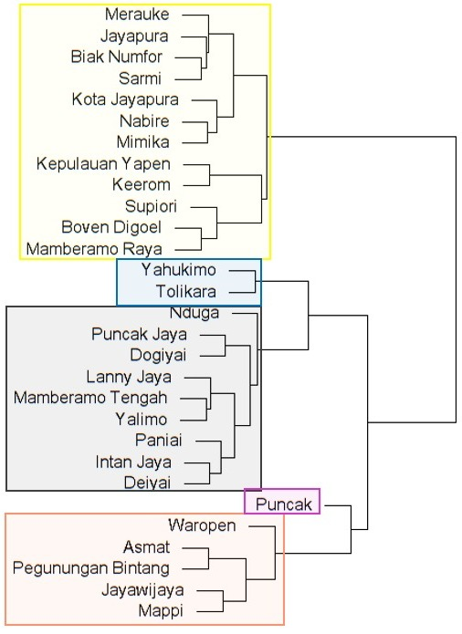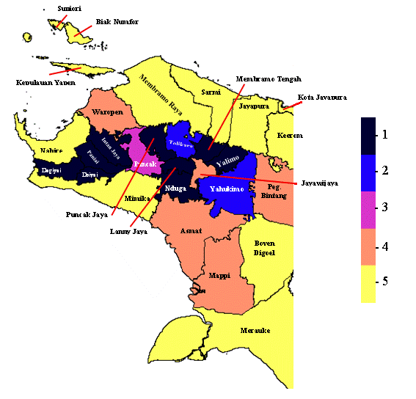
(A) | (B)

Figure 1. (A) Dendrogram of Hierarchical Clustering results and (B) Cluster map of districts/cities in Papua.

Acknowledgment: The Directorate of Research and Development of Universitas Indonesia (DRPM UI) funded this study as an additional paper through a grant of Hibah Publikasi Terindeks International (PUTI) Q2 2022-2023 (No. : NKB-668/UN2.RST/HKP.05.00/2022)

References:
[1] Hall, R. P., Van Koppen, B., & Van Houweling, E. (2014). The Human Right to Water: The Importance of Domestic and Productive Water Rights. Science and Engineering Ethics, 20(4), 849–868. https://doi.org/10.1007/s11948-013-9499-3
[2] Badan Pusat Statistik. (2022). Proporsi Rumah Tangga Yang Memiliki Akses Terhadap Layanan Sanitasi Layak (Persen), 2020-2022. Badan Pusat Statistik. https://www.bps.go.id/indicator/29/1267/1/proporsi-rumah-tangga-yang-memiliki-akses-terhadap-layanan-sanitasi-layak.html
[3] KemenPPN/Bappenas. (2020). Ringkasan Metadata Indikator Tujuan Pembangunan Berkelanjutan (TPB)/Sustainable Development Goals Indonesia (SDGs) (2 ed.). Kementerian Perencanaan Pembangunan Nasional/Bappenas.
[4] Saeed, N., Nam, H., Ul Haq, M. I., & Bhatti, D. M. S. (2018). A Survey on Multidimensional Scaling. Dalam ACM Computing Surveys (Vol. 51, Nomor 3). Association for Computing Machinery. https://doi.org/10.1145/3178155

